**CHAPTER ONE**

**INTRODUCTION**

* 1. **Background of study**

Research on Home Automation devices have been going on for quite some time. These research have produced smart thermostats, switches and wireless controllable lights like Philips Hue. But these devices are mostly out of reach of the general population mainly because of its high cost.

Introduction these smart electrical lights, switches have enabled us to control electrical appliances through our phones. These are low cost devices that can be used to control various electronics that have built-in microcontrollers and wireless connectivity. But sadly, traditional electronics do not contain either microcontrollers, nor have wireless capabilities.

Our solution enables users control to everyday electronics just adding some additional simple components to their existing electronic switches and controls through Android phones.

* 1. **Problem statement**

The problem is that, to use the existing solutions, users need to buy expensive electronics which often include single use lights and socket adapters with built in wireless connectivity which needs to be thrown out after it fuses or breaks down .

In case of switches, users need to replace switches with expensive ones to gain the ability to control them wirelessly. In case of sockets, users need to add additional sockets over wall sockets and it does not provide individual control over each device connected via the

* 1. Motivation

## The objective of this project is to provide a design or pattern that can be used to implement real-time remote control on everyday electronics. The goal of this project is to implement a secure real-time control of home appliances and other electrical components through Mobile Phones.

* 1. Aims and Objectives

## The objective of this project is to provide a design or pattern that can be used to implement real-time remote control on everyday electronics. The goal of this project is to implement a secured real-time control of home appliances and other electrical components through Mobile Phones.

**1.5 Methodology**

i Dart programming language will be used for writing the codes for front end mobile application.

ii The application will be designed using Android studio IDE and flutter SDK

iii Firebase database will be used as the back end of the android application

iv C/C++ programming language will be used to write the programme on the arduino microcontroller

v Arduino microcontroller will serve as the brain of the automation.

vi The ESP8266 is a low-cost [Wi-Fi](https://en.wikipedia.org/wiki/Wi-Fi" \o "Wi-Fi) microchip with full [TCP/IP stack](https://en.wikipedia.org/wiki/TCP/IP_stack" \o "TCP/IP stack)

vii Relay an electromechanical device that is actuated by an electrical current

**1.6 Scope of project**

This project contributes to the IOT ecosystem in the sub-division of Home Automation. This project and its implementation shows a unique way to easily implement real-time monitoring of home appliances. It also shows how to implement a robust, rigid and secure home control and monitoring system using open-source software and simple and inexpensive hardware without replacing existing electrical components.

**1.7 Project organization**

The paper follows a very common organization pattern. The first part starts with the introduction of the project. The second part describes over related work in the same field. The system model has been described in the third part containing description of different components of the system. The fourth part describes the system in action or the system implementation including the implementation and features of Android application, arduino uno and Firebase web service. The technical and non-technical limitations are described in in the fifth part. The paper concludes with hints of future expansion ideas and pathways and lastly, a short conclusion. Additional system diagrams, illustrations and code samples are added as appendix.

**CHAPTER TWO**

**LITERATURE REVIEW**

2.1 Introduction

This chapter reviews the related literature of this study. It explains what Home automation is. It also defines what android Application, Flutter SDK, Firebase, The history of Android itself. So also covers the study of what Biometric is and how it operates.

**2.2 Home automation**

Home automation is similar to digital home, smart home, e-home and intelligent household. They all mean a high living condition with several smart devices. It is the residential extension of automation which is using telecommunication technology, computer technology and automation technology to give the user a better living environment, security and comfort. It helps people to reduce domestic working and household management by its automation and monitoring system.

2.3 Overview of Android Application

An android App is a software application running on android platform. since the android platform is built for mobile devices, a regular android application is intended for a smartphone or a tablet pc running on Android OS. Android Applications are mostly written in either Java, Dart or kotlin programming language.

### 2.3.1 History of Android

Android Inc. was founded by Andy Rubin, Rich Miner, Nick Sears, and Chris White in Palo Alto, California in October 2003, Rubin described the Android project as “tremendous potential in developing smarter mobile devices that are more aware of its owner’s location and preferences”. The main purpose of the company was to develop an advanced operating system for digital cameras, and this was the support of its in investors in April 2004 until when the company decided that the market for cameras was not large enough for its goals. **(Gargenta, 2011, 3-6)**

The actual history of android starts when Google has had purchased and Android Inc. in 2005. But the development did not start immediately. The actual progress on android platform starts when 2007 Open handsets Alliance has announced the Android as Open Source platform and year later the Android SDK 1.0. In the same 2008 the G1 phone was produced by HTC and was retailed within the T-Mobile carrier. In the next two years came out 4 version of Android. In 2010 there were at least 60 devices running on android and it becomes second after blackberry. And now more than a 2 billion android users in the world (Muhammad, Johnson, Basit, Khan, Farhan, 2017).

### 2.3.2 Android Framework

Android is one of an Open source platform. It is made by Google and owned by Open Handset Alliance. It is structured with objective “accelerate innovation in mobile” As such android has taken over a field of mobile innovation. It is definitely free and open platform that differs hardware from software that runs on it. It results for considerably more gadgets be running a similar application. Likewise, it gives plausibility of friendlier condition for developers and consumers. Android is a finished programming bundle for mobile devices. Since the beginning android group offers the developing kit (tool and frameworks) for creating mobile applications fast and simple as could be expected under the circumstances. In a few cases you do not specially need an android phone however you are free to have one. It can work right out of the box, obviously users can modify it for their specific needs. For manufacturers it is ready and free solution for their devices. Except specific drivers’ android community provides everything else to create their devices. (Gargenta 2011, 1-6)

**2.3.3 Dart Programming language**

Dar**t** is a general purpose programming anguage originally developed by Google in 2011 and later approved as a standard by Ecma (ECMA-408). It is used to build web,server, desktop, and mobile applications.Dart is an object oriented, class defined, garbage collected language using a C-style synatax that transcompiles optionally into Javascript. It supports interface, mixins, abstract classes, reified generics, [s](https://en.wikipedia.org/wiki/Static_typing" \o "Static typing)tatic typing, and a sound type system.

**2.3.4 SDK**

A software development kit (SDK or devkit) is typically a set of [software development](https://en.wikipedia.org/wiki/Software_development" \o "Software development) tools that allows the creation of [applications](https://en.wikipedia.org/wiki/Application_software" \o "Application software) for a certain [software](https://en.wikipedia.org/wiki/Software" \o "Software) package, [software framework](https://en.wikipedia.org/wiki/Software_framework" \o "Software framework), hardware platform, [computer system](https://en.wikipedia.org/wiki/Computer_system" \o "Computer system), [video game console](https://en.wikipedia.org/wiki/Video_game_console" \o "Video game console), [operating system](https://en.wikipedia.org/wiki/Operating_system" \o "Operating system), or similar development platform. To enrich applications with advanced functionalities, advertisements, push notifications,and more, most app developers implement specific software development kits.

**2.3.5 Flutter**

Flutter is an open source mobile reactive development framework created by Google officially launched in 2017. It is used to develop applications for Android and Ios, as well as being the primary method of creating applications for Google new Operating system called fuchsia.

Flutter apps are written in the Dart language and make use of many of the language's more advanced features On Android, and on Windows, macOS and Linux via the semi-official Flutter Desktop Embedding as well Humming bird project project for web, Flutter runs in the Dart virtual machine which features a just in time execution engine. Due to App Store restrictions on dynamic code execution, Flutter apps use ahead of time compilation on IOS.A notable feature of the Dart platform is its support for "hot reload" where modifications to source files can be injected into a running application. Flutter extends this with support for stateful hot reload, where in most cases changes to source code can be reflected immediately in the running app without requiring a restart or any loss of state.This feature as implemented in Flutter has received widespread praise.

**2.4 Database**

A **database** is an organized collection of [data](https://en.wikipedia.org/wiki/Data_(computing)" \o "Data (computing)), generally stored and accessed electronically from a computer system. Where databases are more complex they are often developed using formal [design and modeling](https://en.wikipedia.org/wiki/Database" \l "Design_and_modeling) techniques.

**2.4.1 Firebase Database**

Firebase is a NoSQL cloud database. A NoSQL database provides a mechanism for storage and retrieval of data that is modeled in means other than the tabular relations used in relational databases.

The Firebase Realtime Database is a cloud-hosted database. Data is stored as **JSON** and synchronized in realtime to every connected client.

2.5 Biometrics

Biometrics are a way to measure a person’s physical characteristics to verify their identity. These can include physiological qualities, for example, fingerprints and eyes, or behavioral characteristics such as the unique way you complete a security-authentication puzzle. To be helpful, biometric data must be unique, permanent and collectible. Once measured, the information is compared and matched in a database.

Fingerprint recognition looks for the unique patterns of ridges and valleys that are present in an individual’s fingerprint. These patterns are unique to every individual and thus help to identify individuals from an entire population. Fingerprints are inherent to individuals and can neither be lost nor stolen which makes it highly accurate and reliable.

### 2.5.1 Authentication

This is the process of recognizing a user’s identity. It is the component of linking an incoming request with a set of identifying credentials. The credentials provided are contrasted with those on a record of a database of the authorized user’s information on a local operating system or within an authentication server.

**2.6 Microcontroller**

A microcontroller (MCU for *microcontroller unit*) is a small [computer](https://en.wikipedia.org/wiki/Computer" \o "Computer) on a single [integrated circuit](https://en.wikipedia.org/wiki/Integrated_circuit" \o "Integrated circuit). In modern terminology, it is similar to, but less sophisticated than, a [system on a chip](https://en.wikipedia.org/wiki/System_on_a_chip" \o "System on a chip) (SoC); an SoC may include a microcontroller as one of its components. A microcontroller contains one or more [CPUs](https://en.wikipedia.org/wiki/Central_processing_unit" \o "Central processing unit) ([processor cores](https://en.wikipedia.org/wiki/Processor_core" \o "Processor core)) along with [memory](https://en.wikipedia.org/wiki/Computer_memory" \o "Computer memory) and programmable [input/output](https://en.wikipedia.org/wiki/Input/output" \o "Input/output) peripherals.

2.6 Review of Related Work

## Over the last decade, smartphone apps have allowed us to advance the progress of systems and processes that hadn’t changed in years. Twenty years ago, no one ever thought you’d be able to take your phone out of your pocket at work and view the real-time security footage of your home. Today however, that’s only one of the benefits of turning your home into a smart home using home automation. Now, millions of people around the world are also using home automation apps to do things like reduce their home energy usage and run their entertainment systems.

### **Samsung SmartThings:** This app goes beyond the capability of most home automation apps, not only allowing you to control devices such as cameras, locks and thermostats – but also giving you control over Samsung appliances like TVs, washing machines and air conditioners.

### **Sonos Controller:** If you are a music fanatic, today’s technology allows you to build the  epic smart entertainment system that you only dreamed about in the past. The Sonos Controller app connects wirelessly to Sonos speakers and allows you to control music throughout your home

**Philips Hue:** The Phillips Hue app allows you to control the entire range of [Philips Hue smart bulbs](https://www2.meethue.com/en-us/products.bulbs" \l "filters=STARTER_KITS_SU&sliders=&support=&price=&priceBoxes=&page=&layout=12.subcategory.p-grid-icon). Their Smart Bulbs can showcase over 16 million colors and can be dimmed or brightened remotely.

### **Nest:** Nest is known as one of the most innovative companies in the smart device sector. They create a variety of products that are meant to protect and automate your home. Currently, the Nest app focuses on developing devices such as smart cameras, smart doorbells, thermostats, alarm systems, and smoke + CO alarms.

**CHAPTER THREE**

DESIGN OF THE PROPOSE SYSTEM

3.1 Introduction

This chapter describes the architecture of the system which consists of system components and the systems developed. It discuss about the data flow diagram of the system, the flowchart of the system, the use case of the system and the tools of the system.

3.2 Component details

## 3.2.1 Android Application

The proposed Application, which is Fingerprint Authenticated Secure Home Automation Application is an android application that requires android version 4 and above that also comes with a fingerprint feature because of the biometric security needed to pass the first stage and have access to the App.

Once the application is launched and the user is authenticated, he/she will get access to the android application interactive UI which shows all connected electrical equipment and appliances. It shows the present status (or last updated status during internet connection) of all equipment. It also the user to turn on or switch off an appliance.

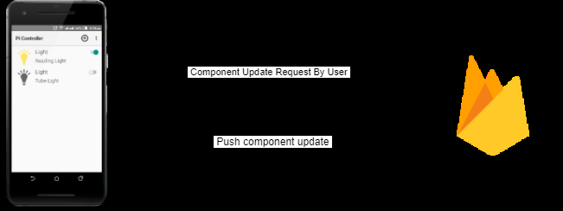

**Firebase**

Firebase has been used as the main database for both the Android Application and the arduino Server. Firebase Realtime Database is a cloud-hosted database. Data is stored as JSON and synchronized in real time to every connected client. All of the clients share one Real time Database instance and automatically receive updates with the newest data. The database maintains information of users and electronic components. Access is limited to authenticated users only. Every user has access to own data only. A sample dataset is shown below.

{ "components" :

[ { "description" : "Reading Light",

"id" : "1001",

"name" : "Light",

"status" : true,

"type" : "light" },

{ "description" : "Tube Light",

"id" : "1002",

"name" : "Light",

"status" : false,

"type" : "light" } ] }

**3.2.3 Arduino uno**

Arduino UNO is an 8 bit microcontroller board which is based on ATmega328P. It comprises of 14 digital input and output pins, a 16 MHZ quartz crystal, USB connection for easy computer connectivity and a reset button to eliminate and restart in case of malfunction. It has an operating voltage of 5V, a flash memory of 32KB and a clock speed of 16 MHz for faster data processing.

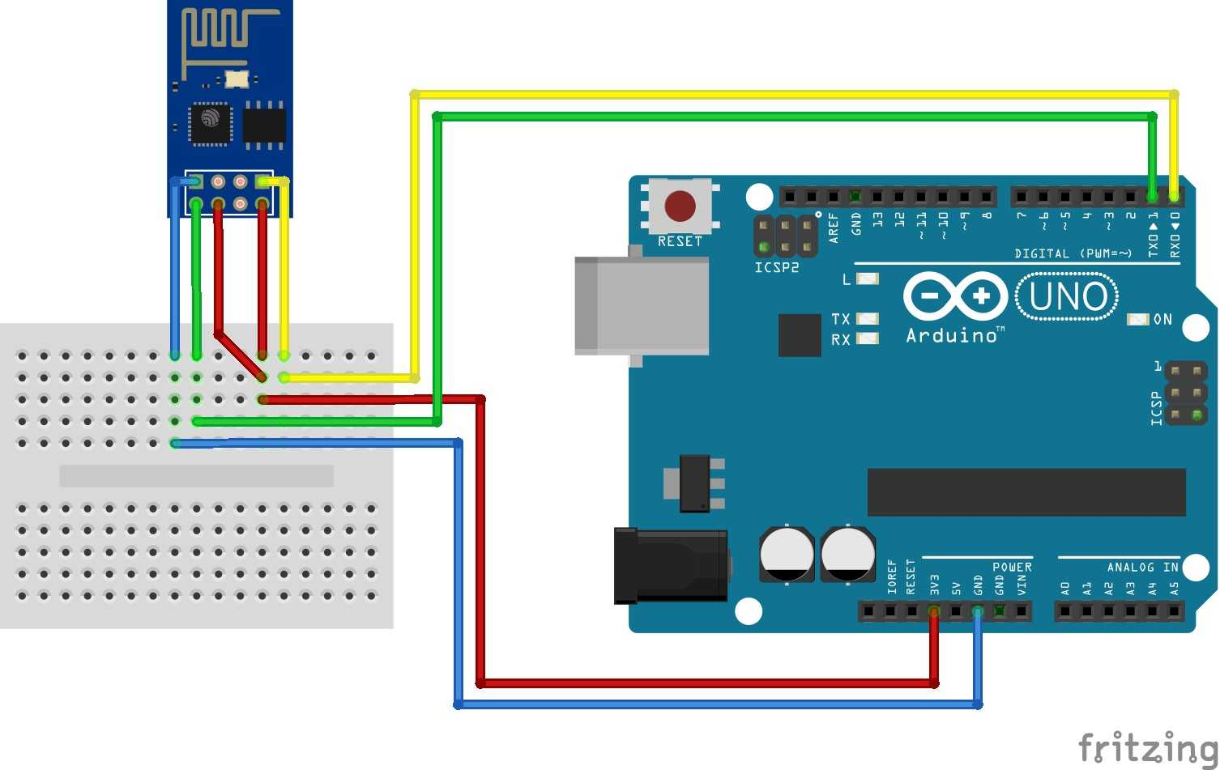

**Software methodology**

Agile software development is a group of software developments methods based on iterative and incremental development, in which requirements and solution evolve through collaboration between self-organizing, cross-functional teams. It promotes adaptive planning, evolutionary development and delivery, a time- boxed iterative approach, and encourages rapid and flexible response to change. It is a conceptual framework that promotes foreseen tight iteration throughout the development cycle.

**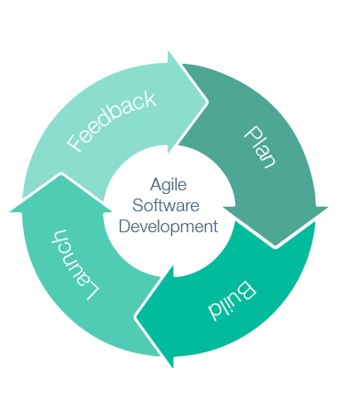**

### 3.3.1 BUILD

Build is the process step where you integrate all or part of your application. The build can include steps like retrieving the correct components from various locations in the repository, compilation, running scripts that generate source files from meta data, etc. the product of a build can be a complete application or a component for distribution.

### 3.3.2 System Architecture

System architecture is where the concepts that will be the backbone of the actual system are developed. It is a conceptual model that describes the structure and behavior of the proposed system or of an existing system. The model could include the technical framework, end user requirements, and a list of system components (hardware and software). The components are describes as:

### 3.3.2 Model

Model manages the information and notifies observers when there is a change of information and also a component to retrieve the data from a database source. Dart programming language is used to implement the Model.

### 3.3.3 Controller

Controller determines what the view displays and how the application should respond. It is also implemented using the dart programming language.

### 3.3.4 View

The view in is responsible for the presentation of the user i.e it controls how data is displayed how users interact with it. Dart programming language is used in achieving the view.

3.4 Flowchart of the System

A flowchart is a diagramatic representation of an algorithm, a step by step approach to solving a task. Each step in the process is represented by a different symbol and contains a short description of the process step. The steps are linked by connecting lines and directional arrows. Figure 3.2 shows the flowchart

3.5 Use Case Diagram

A use case diagram is a behavioral digaram in unified modelling langauge(UML). Use case diagrams model the functionality of a system using actors and use cases. Use cases are a set of actions, services, and functions that the system needs to perform. The actors are people or entities operating under defined roles within the system. Use case diagrams are valuable for visualizing the functional requirements of a system that will translate into design choices and development priorities. They provide a good high level analysis from outside the system. Use case diagrams specify how the system interacts with actors without worrying about the details of how the functionality is implemented. Fig.3.3 illustrates the use case diagram for this application.

3.6 System Requirement

This describes what the system need for it to be considered fully functional. The system requirement can be categorized into two

1. Functional requirement
2. Non-functional requirement.

3.6.1 Functional Requirement:This defines a function of a system or its component, where a function is describes as a specification of behavior between outputs and inputs. In short, there are related to the technical functionality of the system. These include:

1. Authentication

This is the start and can also be the end because without a registered fingerprint on the device settings the user cannot go further. You will need to authenticate your fingerprint by pressing on a **continue** button that will be in the first page we can call that the **login page.**

1. Accessing :

This is where the user add note by first giving the note a title and a priority for better arrangement of the note.

1. Accessing Saved Notes:

User will be able to have access to the note saved immediately after passing the **log in page.**  It will be easier to be access old notes that to even create a new one.

1. Modifying/updating notes:

All notes saved can at any time be modified i.e. Details can be added to the note or deleted at any time needed without having a limit of times to do so.

3.6.2 Non- functional Requirement: this is a requirement that specifies criteria that can be used to judge the operation of a system in particular conditions, rather than specific behaviors. These include the following:

1. Performance:

This means the system will be able to startup in a very short period of time and load initial screen. Also the app shouldn’t hindrance to the user input.

1. Responsiveness:

When interrupted the app should be able to save state and return to same state/page which it was before it got interrupted by maybe a call.

1. Use-ability:

User should be able to understand the flow of app easily i.e. users should be able to use app without guideline or help from experts or manuals.

1. Security:

The app data is encrypted with the highest security while requiring simple detail to gain access to the app i.e. not much detail about the user is needed for it to be secure.

1. Reliability:

The system should not have any unexpected failure. In order to avoid any failures occurrence, the specification have been respected and followed correctly. The only problem the application might have is when using the text-to- speech feature and that can only occur when the network connection is poor.